About

PAWSv2 is a project to occupy my time in retirement (and as it happened the Covid-19 lockdowns), with the aim of teaching myself about FPGA programming. It is based upon the idea of the 8-bit computers and consoles from the 1980s, but using a modern CPU with C compiler support.

A support library, libPAWS, for easy access to the hardware is provided, along with a few sample C programs to test the hardware and the programming library. This documentation details libPAWS and describes the hardware.

PAWSv2 is a development of PAWS. PAWSv2 uses a 256 ( 255 + transparent ) colour display, as opposed to PAWS which uses a 64 ( 63 + transparent ) colour display; sprites are now multi-colour, and are rotatable as well as reflect-able; tilemap tiles are now multi-colour, and are rotatable as well as reflect-able.

CPU Choice

Versions are provided with a 32-bit RV32IMAFCB CPU, single precision floating-point only, and a 64-bit RV64GC CPU, single and double precision floating-point. In general, by using the software library, software can be easily recompiled for each compiler.

Silice

PAWS is coded in Silice, a hardware description language developed by @sylefeb. Details can be found here GitHub ( https://github.com/sylefeb/Silice ).

My coding style may not result in the best design, the aim was to create a design that could be easily understood.

Using PAWS

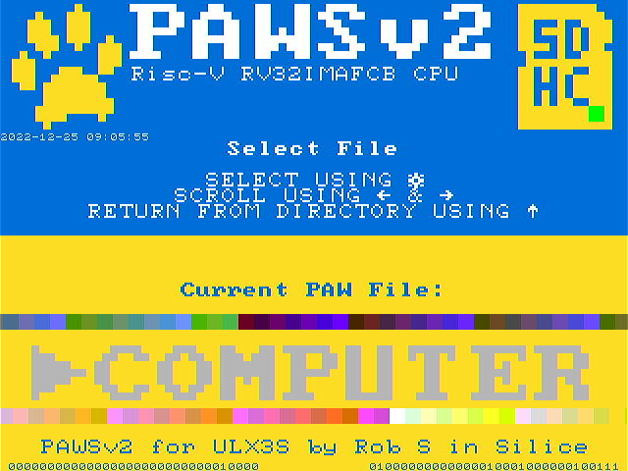
The PAWS BIOS showing the SDCARD loader.

The PAWS system starts in the BIOS, which initialises the system, and starts a file explorer for the PAW (compiled programs) files on the SDCARD. Scroll through the available PAW files using LEFT and RIGHT. Use FIRE 1 to select a PAW file, or to enter a directory. Use UP to return from a directory.

If the SDCARD is not detected, try pressing RESET to reinitialise the system.

There are several example programs provided, showing how to use the PAWS graphics system and other hardware.

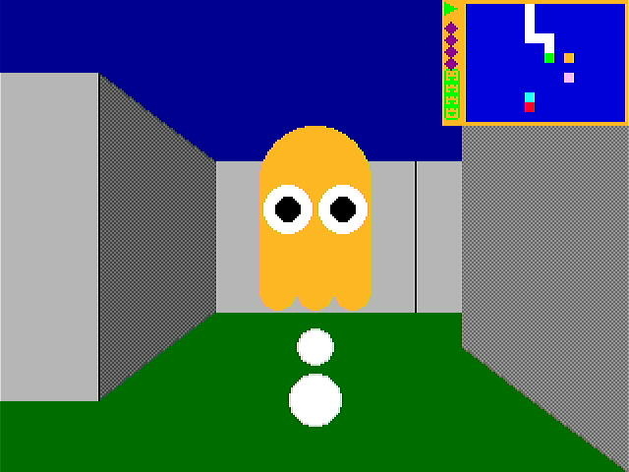
3D Maze

A 3D Maze explorer, based upon the idea of the ZX81’s 3D Monster Maze, but using Pacman Ghosts as the monsters.

Demonstrates GPU shapes, dither patterns, character blitter and pixelblocks (the start, between level and game over screen images), as well as a simple flicker free framebuffer swapping system; the PAWSlibrary functions for creating DrawList2D items, a list of shapes with offset coordinates, that can be scaled and rotated (used for the Pacman ghosts).

A simple tune playing system is also included for the game start tune, using the SMT CPU thread to play the tune and exit when finished.

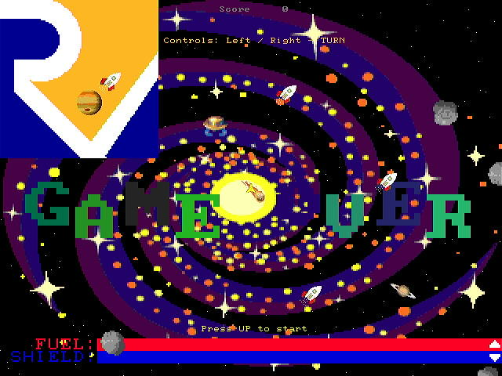
Asteroids

A port of the arcade Asteroids game, using images rather than the original vectors.

Demonstrates the SPRITES, including the collision system and the update system for movement; the TILEMAP for the planets, comets and rocketships; the BACKGROUND COPPER for the rainbow stars backdrop; the SMT CPU thread is used to move the asteroids outside of the main game logic; the AUDIO system for simple sound effects, and the UFO alert uses the DOOM SAMPLE system.

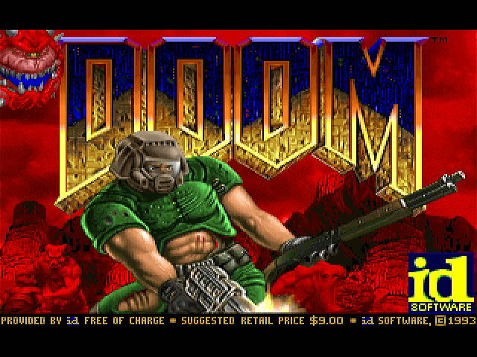 | 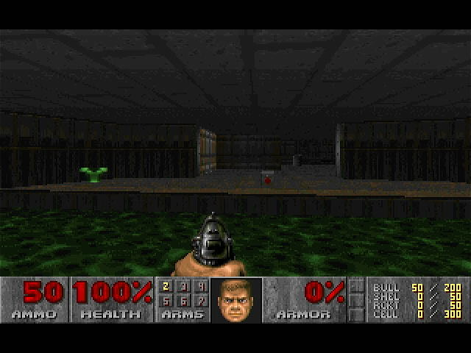
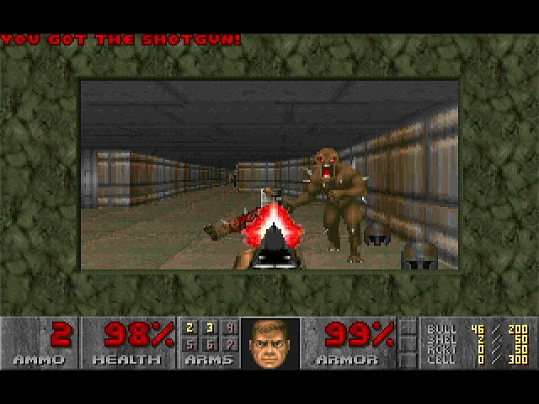 | 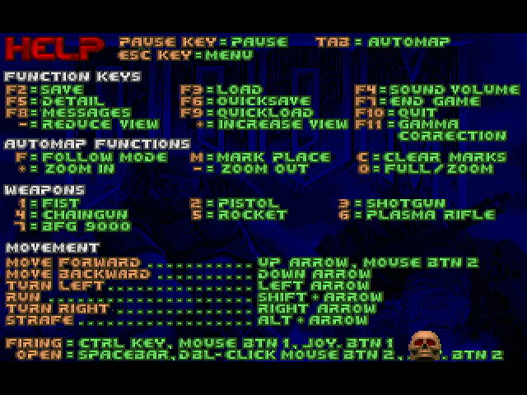
DOOM via https://github.com/mbitsnbites/mc1-doom

A port of the classic DOOM, using mc1-doom as the base addressing the PAWS hardware. Uses the 256 colour bitmap display (no transparency) and the configurable palette to allow the original colour scheme to be used. Sound uses the DOOM PC SPEAKER SAMPLES. Use is made of the DMA engine for rapid transfer of data to/from memory/display and sample loading, and the pixelblock functions for drawing the to the framebuffer when transfer DOOM sprites to the display with scaling.

To speed up the game to a more playable speed, use the (not numerical keypad) + and – to increase or decrease the size of the game window. W A S D are used to move the player, left and right arrow are used for turning. Right CTRL is used for firing.

DOOM1.WAD ( https://doomwiki.org/wiki/DOOM1.WAD ) will need to be copied into the /GAMES directory on the SDCARD. Game saving does not presently work.

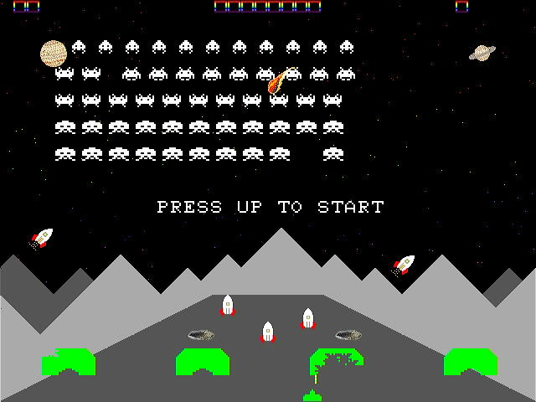
Space Invaders

A port of the arcade Space Invaders.

Demonstrates SPRITE collision detection between the display layers; flicker free animation using the two frame buffers, and drawing to both framebuffers simultaneously to draw and update the bunkers.

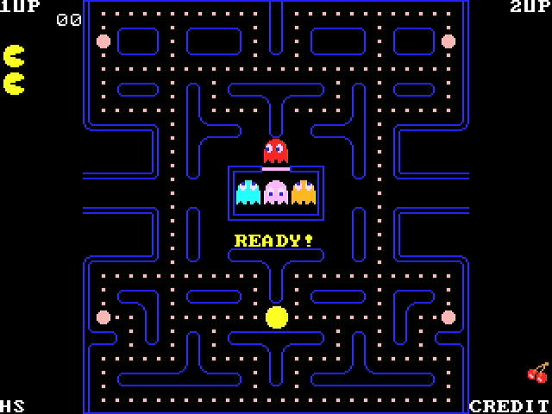
Pacman ported from https://github.com/floooh/pacman.c

A port of the arcade Pacman.

Demonstrates the use of TILEMAPS for the maze, including the dots and power pills; SPRITES for the player character and the ghosts; the DOOM SAMPLE AUDIO system for the sound effects.

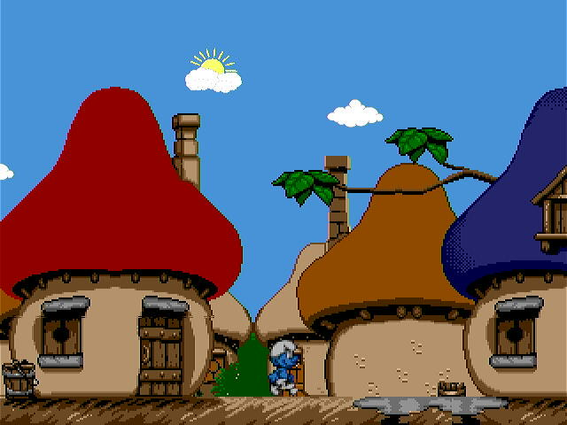
Smurfs (technology demonstration)

Demonstrates the use of simultaneous display of the BITMAPS to provide a parallax scrolling effect; the PAWSlibrary functions for displaying multiple sprites as a single SPRITE, including reflecting and animating; the DMA engine for fast copying to the BITMAP framebuffers extracting sections of the backdrops.

Controlling PAWS via ULX3S Buttons or PS/2 Keyboard

By default, the PS/2 keyboard is mapped as a joystick, with the buttons identified as below.

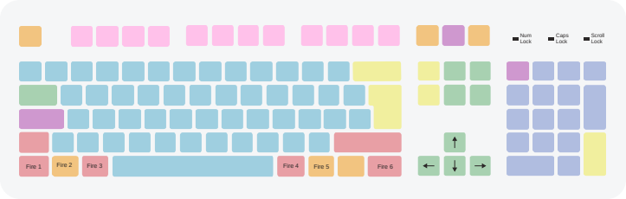

The BIOS can be controlled using either the ULX3S buttons, or the above keyboard keys.

Note: The PS/2 system is not perfect, it does not always reset. It may be necessary to disconnect and reconnect the keyboard for it to reinitialise. I use the CiT KB2106C keyboard which is known to work in PS/2 mode with the ULX3S.
PAWS Features

- Dual Thread Risc-V RV32IMAFCB CPU
  - Small on CPU INSTRUCTION CACHE (as per 68010)
  - No interrupts
  - No SYSTEM functions or memory protection
- 32MB of SDRAM with 16K directly mapped eviction cache.
- 32K of FAST BRAM (used for BIOS and CPU STACKS)
- 32K of I/O MEMORY MAPPED REGISTERS

- PS/2 Keyboard
  - Joystick emulation mode available
- 115200 baud UART
- ULX3S Buttons and LEDS
- SDCARD with FAT32 with DMA for transfer to/from memory
- 1hz and 1khz Timers
- Real Time Clock Support
- Pseudo Random Number Generators (Integer and floating point)
- Simple Stereo Audio
  - Square, Sawtooth, Triangle and Sine Waves, plus Noise
  - DOOM PC Speaker style sample support

- Multi-Layered Display ( 256 colours where available, with transparency, optional palette mode )
  - TERMINAL
    - 80 x 8 WHITE on BLUE
  - CHARACTER MAP
    - 80 x 60 COLOUR, NORMAL and BOLD FONTS
      - Switchable to 40 x 30 double size
  - SPRITES
    - 2 LAYERS OF 16 16x16 COLOUR SPRITES
  - TILEMAP
    - 2 LAYERS OF 42x32 16x16 COLOUR TILES
      - 40 x 30 DISPLAYED with SCROLLING
      - Switchable to 20 x 15 double size
  - BITMAP
    - DOUBLE BUFFERED 320 x 240 COLOUR BITMAP
      - HARDWARE ASSISTED DRAWING OF
        - Points
        - Lines/Wide Lines
        - Filled Rectangles
        - Circles, Filled and Outline, with 8 sector mask
        - Filled Triangles/Quadrilaterals
        - Single colour and colour blitters
        - Vectors
      - Memory addressable with DMA support
    - PROGRAMMABLE BACKGROUND DISPLAY

PAWS CPU and SOC

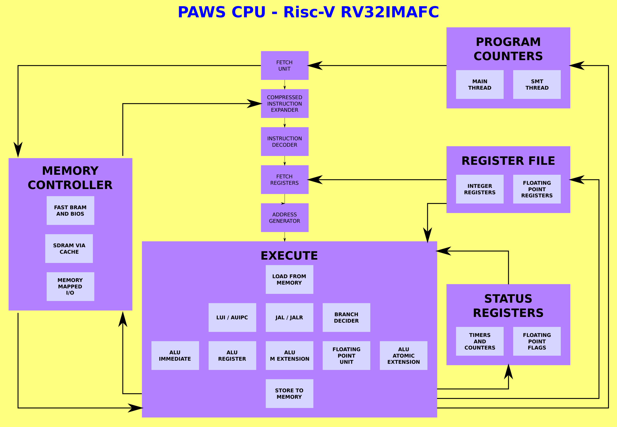

The PAWS CPU is a Risc-V RV32IMAFCB that implements only the features needed to run GCC compiled code.

- No interrupts.
- Machine mode only.

The PAWS CPU has two modes:

- Single thread using all available cycles.
- Dual thread
  - Execute an instruction from each thread alternatively.
  - Second thread can be stopped/started as required.

Supported Instruction Set Listing

Risc-V | Implemented | Not Implemented | Notes
BASE | ADD[I] SUB  SLT[I][U]  AND[I] OR[I] XOR[I]  SLL[I] SRL[I] SRA[I]  AUIPC/LUI
BASE  unconditional jumps | JAL[R}
BASE  conditional brnaches | BEQ/BNE  BLT[U]  BGE[U]
BASE  load and store | LB[U] LH[U] LW  SB SH SW
BASE | FENCE FENCE.I |  | Limited, to reset the L0 instruction cache, or to prevent thread switching.
BASE and F EXTENSION  CSR | RDCYCLE[H]  RDTIME[H]  RDINSTRET[H]  F[R][S]CSR  F[R][S]RM  F[R][S]FLAGS  FS[RM][FLAGS]I |  | Timers and instruction retired counters are readonly.
BASE  SYSTEM |  | ECALL EBREAK
M EXTENSION | DIV[U] REM[U]  MUL MULH[[S]U]
A EXTENSION | AMOADD AMOSWAP  AMOAND AMOOR AMOXOR  AMOMAX[U] AMOMIN[U] |  | AQ / RL flags are ignored.  The AMO instructions do operate as a complete READ-MODIFY_WRITE operation, as intended.
F EXTENSION | FLW FSW  F[N]M[ADD][SUB].S  FADD.S FSUB.S  FMUL.S FDIV.S  FSQRT.S  FSNJ[N][X].S  FMIN.S FMAX.S  FCVT.W[U].S FCVT.S.W[U]  FMV.X.W FMV.W.X  FEQ.S FLT.S FLE.S  FCLASS.S |  | There is no rounding control.
B EXTENSION | SH1ADD SH2ADD SH3ADD  ANDN ORN XNOR  CLZ CPOP CTZ  MAX[U] MIN[U]  ORC.B REV8  ROL ROR[I]  SEXT.B SEXT.H ZEXT.H  CLMUL CLMULH CLMULR  BCLR[I] BEXT[I] BINV[I] BSET[I]  XPERM4 XPERM8 |  | Requires GCC 12 and BINUTILS 2.38.

Compiling Programs For PAWS

The default language for PAWS is C, specifically GCC.

To create a program for PAWS, duplicate the template directory, rename template.c and give your program a name and destination in the makefile.

Contents of template.c | Explanation
#include <PAWSlibrary.h>  int main( void ) {  // CODE GOES HERE  }  // EXIT WILL RETURN TO BIOS | Use libPAWS for definitions and helper functions, must be the last include as overrides entires in other standard C libraries.  Main loop.

Compile your code using make. This will compile your program to a PAW file in the destination directory that can be copied to the SDCARD for loading via the BIOS.

PAWS uses newlib to provide a C library and some auxiliary floating-point routines, and libgcc to provide additional floating-point routines (such as single precision to double precision). The makefile will link to these libraries installed in their default locations on ArchLinux.

PAWS Memory System

The SDRAM has a 16k directly mapped eviction cache. A directly mapped cache was used to simplify the cache logic, and an eviction method chosen to reduce the number of SDRAM writes.

Memory access are organised as 32 bit with the cache acting as a multiplexer to the 16 bit width of the SDRAM chip on the ULX3S.

Memory Management

The BIOS will initialise the memory, and allocates space at the top of fast BRAM memory for the CPU STACKS ( MAIN and SMT THREADS ).

Address Range | Memory Type | Usage
0x00000000 – 0x00008000 | Fast BRAM | 0x0000 – 0x1000 BIOS  0x8000 – 0x4000 Main Stack  0x4000 – 0x2000 SMT Stack  0x1800 – 0x17ff libPAWS  0x1800 – 0x2000 fast storage
0x00008000 – 0x0000ffff | I/O Registers | Commuincation with the PAWS hardware.  No direct hardware access is required, as libPAWS provides functions for all aspects of the PAWS hardware.
0x2000000 - 0x2012bff  0x2020000 - 0x2032bff | Bitmap framebuffer (0, rear)  Bitmap framebuffer (1, front) | CPU access to the bitmap framebuffers. Read access is only possible if the framebuffer is not being displayed. Write access is only possible if the framebuffer is not being used by the GPU.  If both framebuffers are being displayed, framebuffer 1 displays over framebuffer 0.
0x4000000 - 0x7ffffff | SDRAM  PROGRAM + LOADED DATA  MALLOC ALLOCATED MEMORY | Program and data storage. Accessed via a cache.

Standard C library functions for memory management such as malloc are available via newlib. See newlib documentation for details.
Colours

PAWS allows 255 + TRANSPARENT colours to be displayed. There are 2 colour modes. If required, the bitmap layer can be switched to 256 colours, with no transparency.

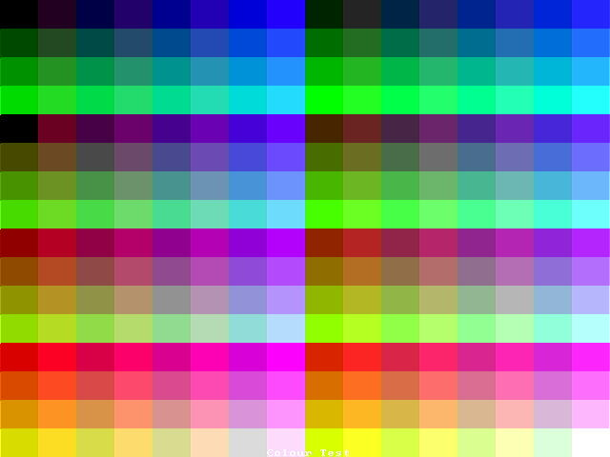 | 
MODE_RGBM  The colour number maps to RRGGGBBM. | MODE_GREY  The colour number maps to a greyscale level.

The MODE_RGBM palette can be replaced with 256 user defined RGB colours.

Some display layers allow for a transparency attribute to allow lower layers to show. This is named TRANSPARENT in libPAWS.
Display Structure

The display in PAWS is organised in layers. The arrangement of the layers can be adjusted, with the background layer always being at the bottom.

The default arrangement of layers (top to bottom) is:

- Terminal Layer (hidden by default)
- Character (Text) Layer
- Upper Sprite Layer
- Bitmap Layer(s)
- Lower Sprite Layer
- Upper Tile Map Layer
- Lower Tile Map Layer
- Background Layer

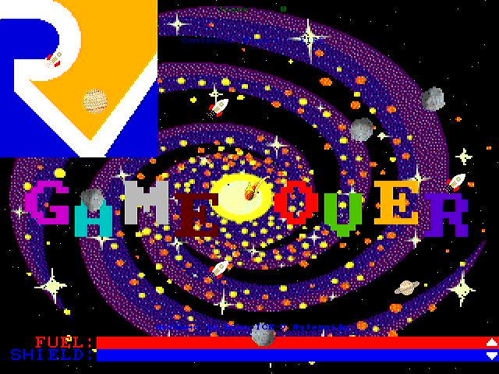
PAWS Asteroids, showing the background (dark blue and falling stars), the bitmap (logo, galaxy image, “GAME OVER” and the fuel bars), the tile maps (the small planets and rocket ships), the sprites (asteroids, UFO, player ship), and the character map (player score and instructions).

PAWS Asteroids runs in screen mode 2, where the bitmap is displayed below the sprites and the tile maps.

libPAWS Variables and Functions

void await_vblank( void ) | Waits for the screen vertical blank to start.
void await_vblank_finish( void ) {  while( *VBLANK );  } | Waits for the screen vertical blank to finish.
void screen_dimmer( unsigned char dimmerlevel ) | Set the screen dimmer level, 0 is full brightness, 1 – 7 progressively half the brightness, 8 is off.
void screen_mode( unsigned char screenmode, unsigned char colour, unsigned char resolution ) | Changes the display layer order, selects the colour mode, switches the tilemaps and/or character maps to double size.  LTM_LOW UTM_LOW CM_LOW are defined in the library as flags to selectwhich layers to double.

File Management

libPAWS has the ability to select and load files from the SDCARD directly into memory.

libPAWS variables and functions

unsigned char *sdcard_selectfile( char *message, char *extension, unsigned int *filesize ) | Returns a pointer to a file that has been loaded into memory, or NULL if no file found.  Message is displayed above the file selector. Only directories and files of the type “extension” will be displayed.

Example code for loading a JPG into memory via the file selector, decoding and displaying.
#include <stdlib.h>
#include <PAWSlibrary.h>

int main( void ) {
INITIALISEMEMORY();

int width, height; unsigned int filesize;
unsigned char *imagebuffer, colour, *filebuffer;

filebuffer = sdcard_selectfile( "Please select a JPEG", "JPG", &filesize );

// JPEG LIBRARY
if( filebuffer ) {
njInit();
njDecode( filebuffer, filesize );
width = njGetWidth();
height = njGetHeight();
imagebuffer=njGetImage();
gpu_pixelblock24( 0, 0, width, height, imagebuffer );
free( filebuffer );
} else {
gpu_print_centre( WHITE, 160, 120, 0, 0, "NO FILE FOUND!" );
}

sleep( 4000, 0 );
}

In addition, standard C file handling functions are available.
Single Thread or Dual Thread Mode

On startup PAWS runs in single thread mode. The BIOS will switch back to single thread mode when returning to the BIOS from a program running in dual thread mode.

Whilst dual thread mode is activated PAWS will execute one instruction from each thread alternatively. All memory is shared, with no memory protection.

The Risc-V A Extension (Atomic Instructions) are decoded and executed, but ignoring the aq and rl flags. The whole of the fetch-modify-write cycle will complete before allowing the other thread to execute.

libPAWS variables and functions

void SMTSTOP( void )void SMTSTART( unsigned int code ) | Stops the SMT thread.
void SMTSTART( unsigned int code ) | Starts the SMT thread, jumping immediately to the address of the function provided.

Due to the way that all of the I/O operations are memory mapped there are considerations to make when writing dual threaded code. Only one thread should attempt to use a section of the graphics system.

Example code for a simple dual thread program
#include <PAWSlibrary.h>

void smtthread( void ) {
// SETUP STACKPOINTER FOR THE SMT THREAD
asm volatile ("li sp ,0x4000");
while(1) {
gpu_rectangle( rng( 64 ), rng( 640 ), rng( 432 ), rng( 640 ), rng( 432 ) );
sleep( 500, 1 );
}
}

void main( void ) {
INITIALISEMEMORY();

tpu_printf_centre( 27, TRANSPARENT, GREEN, "SMT Test" );
tpu_printf_centre( 28, TRANSPARENT, YELLOW, "I'm Just Sitting Here Doing Nothing" );
tpu_printf_centre( 29, TRANSPARENT, BLUE, "The SMT Thread Is Drawing Rectangles!" );
SMTSTART( (unsigned int )smtthread );

while(1) {
tpu_set( 1, 1, TRANSPARENT, WHITE );
tpu_printf( "Main Thread Counting Away: %d", systemclock() );
sleep( 1000, 0 );
}
}

NOTE: The first line of code in the smtthread function must set the stack pointer to the reserved memory in the fast BRAM.

Background Generator

The background layer shows when there is nothing to display from the layers above. There are 16 named background generators in libPAWS. The result of the individual background generators are shown in the table below.

Result of set_background( PURPLE, ORANGE, value from table );
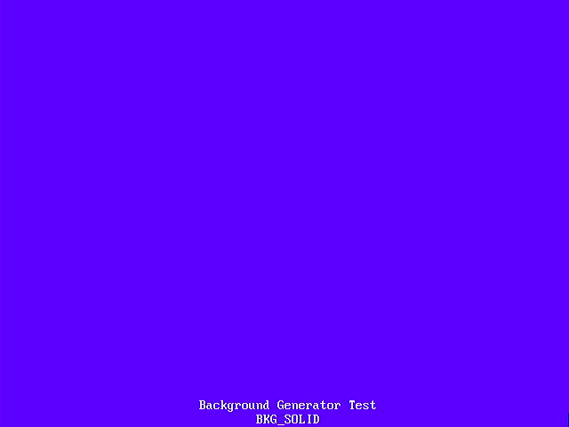  BKG_SOLID | 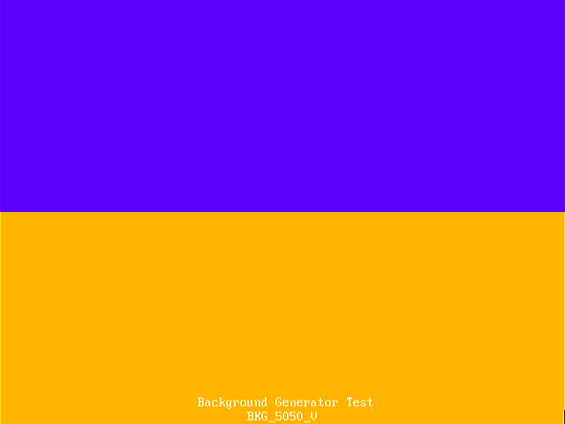  BKG_5050_V | 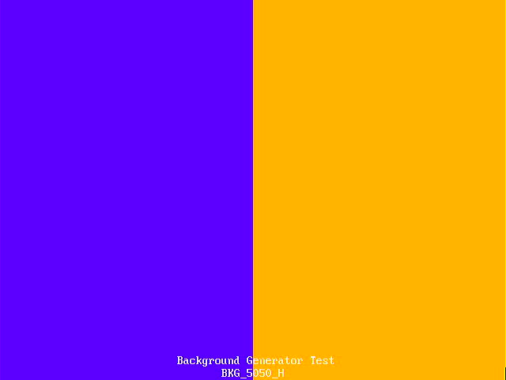  BKG_5050_H | 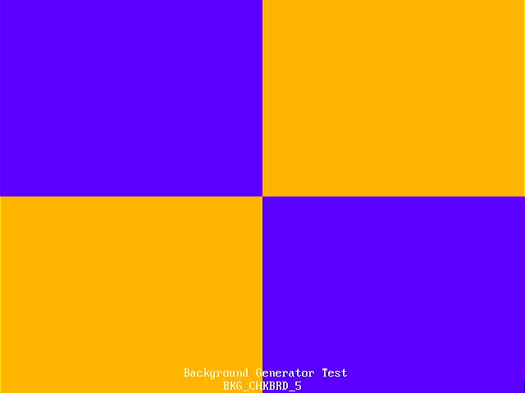  BKG_CHKBRD_5
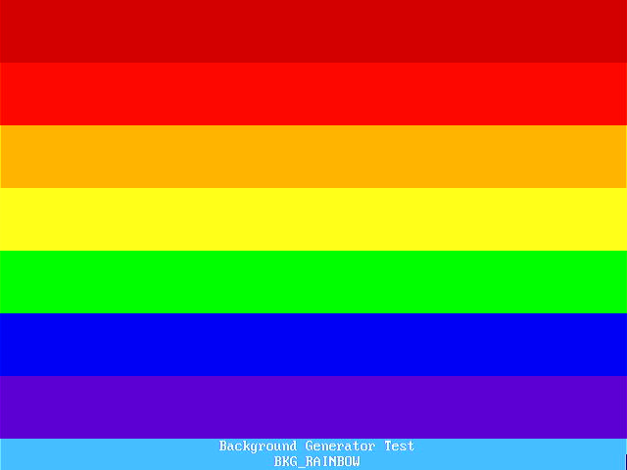  BKG_RAINBOW | 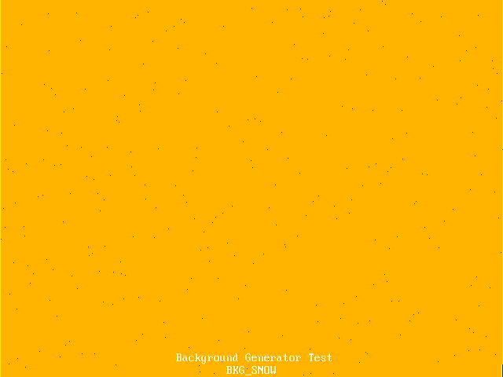  BKG_SNOW | 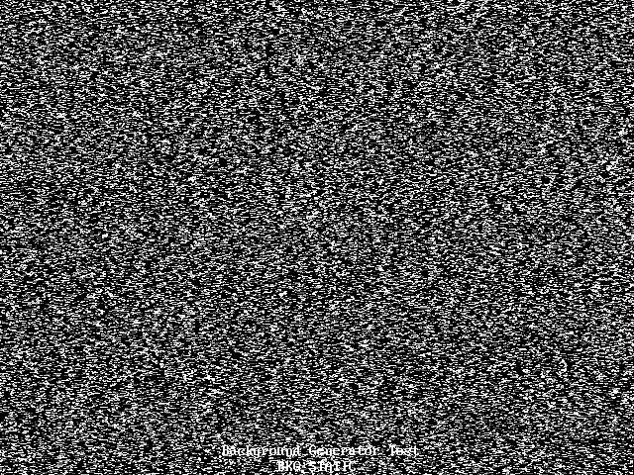  BKG_STATIC | 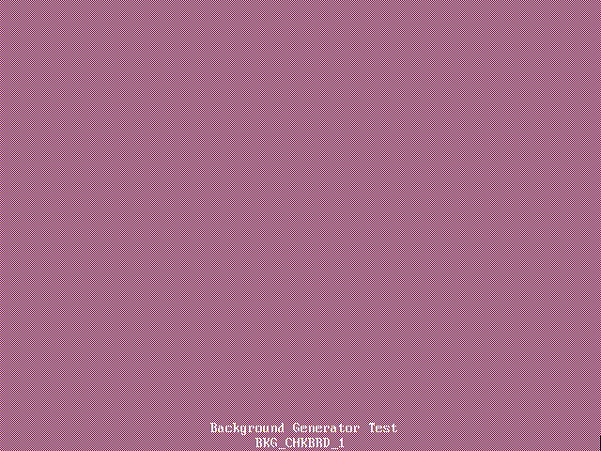  BKG_CHKBRD_1
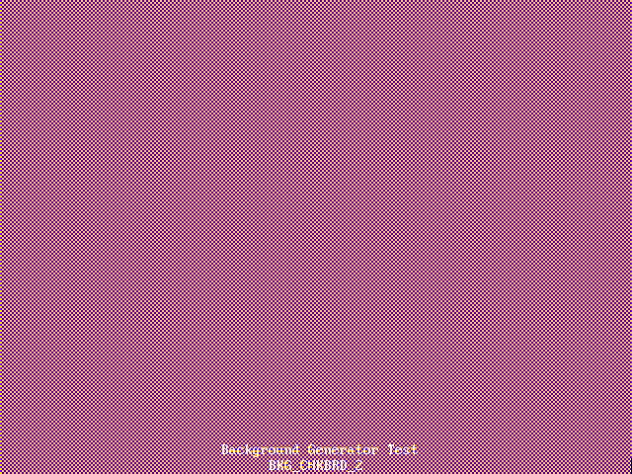  BKG_CHKBRD_2 |   BKG_CHKBRD_3 | 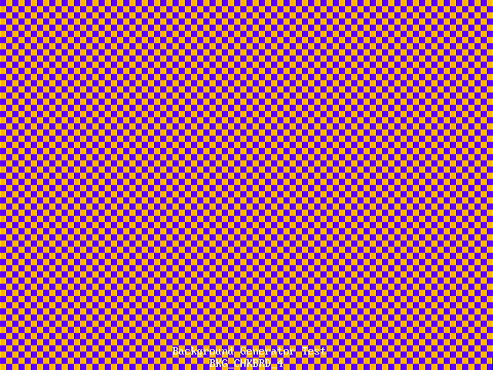  BKG_CHKBRD_4 | 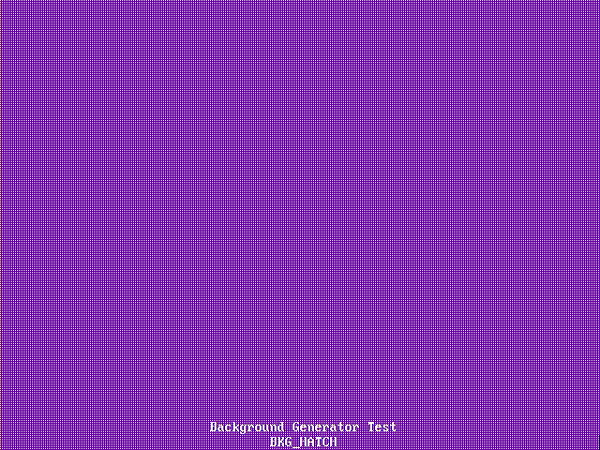  BKG_HATCH
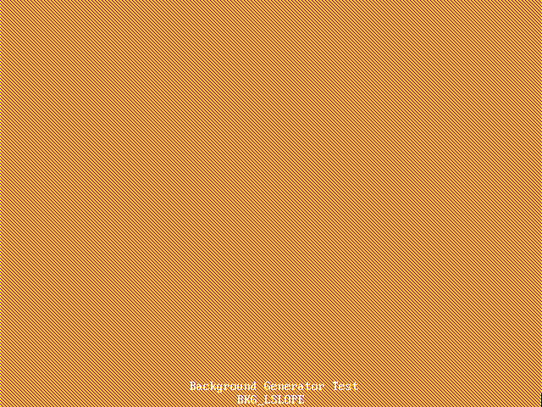  BKG_LSLOPE | 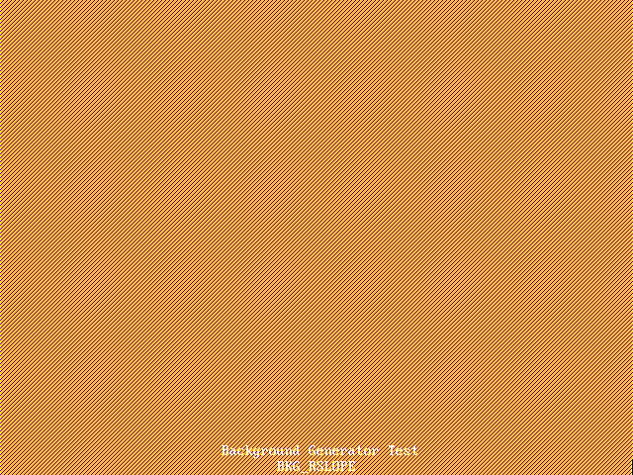  BKG_RSLOPE | 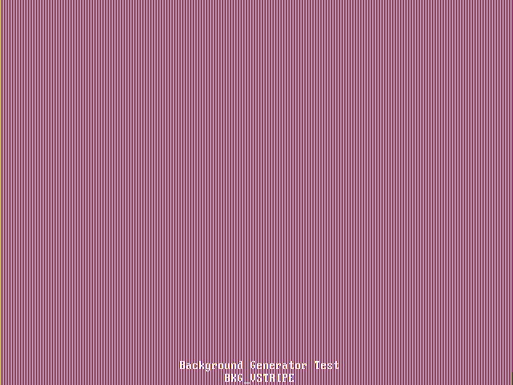  BKG_VSTRIPE | 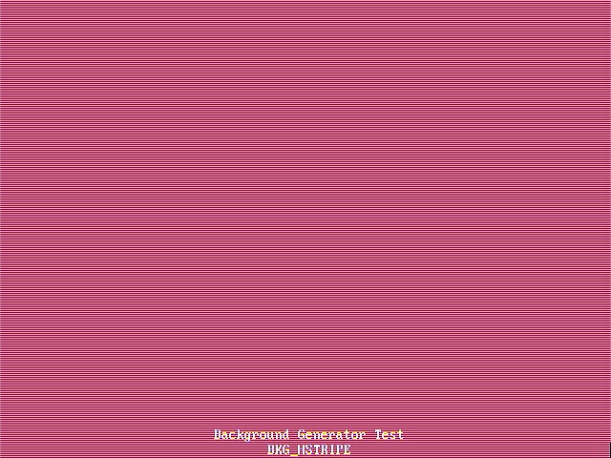  BKG_HSTRIPE

In addition, a simple co-processor, called COPPER, is available to change background generator parameters during the frame generation.
Background COPPER Programming

The COPPER is designed to allow the changing of the background generator parameters during the display frame. The COPPER program storage has 256 entries, there is one variable, and it can detect the present X and Y coordinates (range X = 0 to 639, Y = 0 to 479 ).

COMMAND | CONDITION | VALUE | MODE | ALT | COLOUR /  ADDRESS
JUMP | ALWAYS |  |  |  | ADDRESS | Jump to ADDRESS
JUMP | IF_VBLANK_EQUAL | 0 or 1 |  |  | ADDRESS | Jump to ADDRESS if VBLANK is 0 or 1
JUMP | IF_HBLANK_EQUAL | 0 or 1 |  |  | ADDRESS | Jump to ADDRESS if HBLANK is 0 or 1
JUMP | IF_Y_LESS | Y COORDINATE* |  |  | ADDRESS | Jump to ADDRESS if Y is LESS THAN VALUE
JUMP | IF_X_LESS | X COORDINATE* |  |  | ADDRESS | Jump to ADDRESS if X is LESS THAN VALUE
JUMP | IF_VARIABLE_LESS | VALUE* |  |  | ADDRESS | Jump to ADDRESS if VARIABLE is LESS THAN VALUE
WAIT_VBLANK | SET FLAGS |  | MODE | ALT | COLOUR | Wait for VBLANK and SET
WAIT_HBLANK | SET FLAGS |  | MODE | ALT | COLOUR | Wait for HBLANK and SET
WAIT_Y | SET FLAGS | Y COORDINATE* | MODE | ALT | COLOUR | Wait for Y and SET
WAIT_X | SET FLAGS | X COORDINATE* | MODE | ALT | COLOUR | Wait for X and SET
WAIT_VARIABLE | SET FLAGS | X/Y FLAG | MODE | ALT | COLOUR | Wait for VARIABLE to be EQUAL to X or Y
SET_VARIABLE | 1 | VALUE* |  |  |  | Set VARIABLE to VALUE
ADD_VARIABLE | 2 | VALUE* |  |  |  | Add VALUE to VARIABLE
SUB_VARIABLE | 4 | VALUE* |  |  |  | Subtract VALUE from VARIABLE
SET_FROM_VARIABLE | SET_FLAGS |  |  |  |  | SET from VARIABLE
* the value can be replaced with the constant ‘COPPER_USE_CPU_INPUT’ which will then compare/use the value set by the libPAWS function set_copper_cpuinput( value ).

A simple COPPER program that sets the background generator to the BKG_SNOW pattern on a BLACK background, and changes the colour of the snow/stars every 64 pixels down the screen to give a rainbow effect.
copper_startstop( 0 );
copper_program( 0, COPPER_WAIT_Y, 7, 0, BKG_SNOW, BLACK, WHITE );
copper_program( 1, COPPER_WAIT_X, 7, 0, BKG_SNOW, BLACK, WHITE );
copper_program( 2, COPPER_JUMP, COPPER_JUMP_IF_Y_LESS, 64, 0, 0, 1 );
copper_program( 3, COPPER_WAIT_X, 7, 0, BKG_SNOW, BLACK, RED );
copper_program( 4, COPPER_JUMP, COPPER_JUMP_IF_Y_LESS, 128, 0, 0, 3 );
copper_program( 5, COPPER_WAIT_X, 7, 0, BKG_SNOW, BLACK, ORANGE );
copper_program( 6, COPPER_JUMP, COPPER_JUMP_IF_Y_LESS, 160, 0, 0, 5 );
copper_program( 7, COPPER_WAIT_X, 7, 0, BKG_SNOW, BLACK, YELLOW );
copper_program( 8, COPPER_JUMP, COPPER_JUMP_IF_Y_LESS, 192, 0, 0, 7 );
copper_program( 9, COPPER_WAIT_X, 7, 0, BKG_SNOW, BLACK, GREEN );
copper_program( 10, COPPER_JUMP, COPPER_JUMP_IF_Y_LESS, 224, 0, 0, 9 );
copper_program( 11, COPPER_WAIT_X, 7, 0, BKG_SNOW, BLACK, LTBLUE );
copper_program( 12, COPPER_JUMP, COPPER_JUMP_IF_Y_LESS, 256, 0, 0, 11 );
copper_program( 13, COPPER_WAIT_X, 7, 0, BKG_SNOW, BLACK, PURPLE );
copper_program( 14, COPPER_JUMP, COPPER_JUMP_IF_Y_LESS, 288, 0, 0, 13 );
copper_program( 15, COPPER_WAIT_X, 7, 0, BKG_SNOW, BLACK, MAGENTA );
copper_program( 16, COPPER_JUMP, COPPER_JUMP_IF_NOT_VBLANK, 0, 0, 0, 15 );
copper_program( 17, COPPER_JUMP, COPPER_JUMP_ALWAYS, 0, 0, 0, 1 );
copper_startstop( 1 );

Bitmap and GPU

PAWS displays a 320x240 pixel bitmap with 255 colours, plus TRANSPARENT, with an option to display all 256 colours. PAWS uses a GPU to draw to the bitmap, with hardware accelerated drawing of some graphic primitives.

Basic Principles

The bitmap is 320 pixels wide by 240 pixels tall, with (0,0) being located at the top left-hand corner of the screen. Drawing can be limited to a “cropping rectangle”, only pixels within the “cropping rectangle” will be drawn.

void bitmap_display( unsigned char framebuffer ) | Display bitmap 0 or 1.
void bitmap_draw( unsigned char framebuffer ) | Draw to bitmap 0 or 1.
void bitmap_256( unsigned char mode ) | Switch 256 display mode on or off.
void gpu_crop( unsigned short left, unsigned short right, unsigned short top, unsigned short bottom ) | Sets the cropping rectangle for the GPU. gpu_crop( CROPFULLSCREEN ) will return to the whole of the screen.
void gpu_cs( void ) | Clears the bitmap to TRANSPARENT.

Example code for a tear-free animation
#include <PAWSlibrary.h>

void main( void ) {
// CURRENT FRAMEBUFFER
unsigned short framebuffer = 1;

INITIALISEMEMORY();

while(1) {
// DRAW TO HIDDEN BITMAP
bitmap_draw( 3 - framebuffer );

// CODE TO GENERATE THE BITMAP
// DRAWN TO THE HIDDEN BITMAP

// SWITCH THE FRAMEBUFFER
await_vblank();
framebuffer = 3 - framebuffer;
bitmap_display( framebuffer );
}
}

Dither Patterns

When drawing rectangles, filled circles or triangles, the GPU can apply one of 16 “dither” patterns. The “dither” routine determines whether to use the main drawing colour, provided with the shape being drawn, or the alternate colour, set with the “dither mode”.

void gpu_dither( unsigned char mode, unsigned char colour ) | Sets the dither mode and the alternate colour.

Result of gpu_dither( dithermode, PURPLE ); Plus drawing a rectangle in ORANGE.
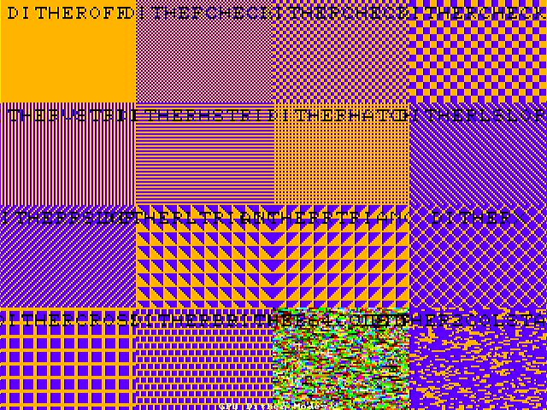

Graphic Primatives

void gpu_pixel( unsigned char colour, short x, short y ) | Draws a pixel at (x,y) in colour.
void gpu_line( unsigned char colour, short x1, short y1, short x2, short y2 ) | Draws a line from (x1,y1) to (x2,y2) in colour.
void gpu_wideline( unsigned char colour, short x1, short y1, short x2, short y2, unsigned short width ) | Draws a line from (x1,y1) to (x2,y2) in colour, width pixels wide.  Effectively draws a parallelogram. Steep lines with the flat sides horizontal, shallow lines with the flat sides vertical.
void gpu_rectangle( unsigned char colour, short x1, short y1, short x2, short y2 ) | Draws a filled rectangle with corners at (x1,y1) and (x2,y2) in colour. Uses the dither mode.
void gpu_circle( unsigned char colour, short x1, short y1, short radius, unsigned char drawsectors, unsigned char filled ) | Draws a circle at centre (x1,y1) of the given radius in colour, optionally filled. Uses the dither mode when filling.  See below for details of the drawsectors parameter.
void gpu_triangle( unsigned char colour, short x1, short y1, short x2, short y2, short x3, short y3 ) | Draws a filled triangle with vertices (x1,y1), (x2,y2) and (x3,y3) in colour. Uses the dither mode.
void gpu_quadrilateral( unsigned char colour, short x1, short y1, short x2, short y2, short x3, short y3, short x4, short y4 ) | Draws a filled convex quadrilateral with vertices (x1,y1), (x2,y2), (x3,y3) and (x4,y4) in colour. Uses the dither mode.  NOTE: Drawn by breaking into two triangles, so vertices should be presented either anti-clockwise or clockwise.

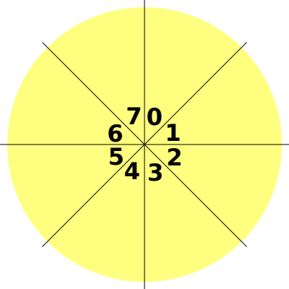 | The drawsectors parameter is an 8-bit binary mask that specifies which of the 45° sectors will be drawn. The bit position that represents each sector is as shown.

Blitters

The blitter copies a tile to the bitmap, drawing pixels where there is a set bit in the tile, and ignoring clear bits in the tile (treating them as transparent). Pixels are drawn in the specified colour without dither patterns being applied. The colour blitter does the same, except that the tile describes a 255 colour image, with transparent pixels being ignored.

The blit_size parameter specifies the size of the output.

blit_size | Size of gpu_blit and gpu_colourblit output | Size of gpu_character_blit
0 | 16x16 | 8x8
1 | 32x32 | 16x16
2 | 64x64 | 32x32
3 | 128x128 | 64x64

The action parameter specifies the reflection or rotation of the tile when draw to the screen.

action | Result
0 | No effect (no reflection)
1 ( REFLECT_X ) | Reflect in X axis
2 ( REFLECT_Y ) | Reflect in Y axis
3 ( REFLECT_X | REFLECT_Y ) | Reflect in X and Y axes
4 ( ROTATE0 ) | No effect (rotate 0 degrees)
5 ( ROTATE90 ) | Rotate 90 degrees anti-clockwise
6 ( ROTATE180 ) | Rotate 180 degrees anti-clockwise
7 ( ROTATE270 ) | Rotate 270 degrees anti-clockwise

Tile Blitter

The tile blitter uses 16x16 tiles, 64 are available, with the tiles being set using the set_blitter_bitmap function, which takes a pointer to an array of 16 unsigned short.

void gpu_blit( unsigned char colour, short x1, short y1, short tile, unsigned char blit_size, unsigned char action ) | Blit a 16x16 tile to (x1,y1) in colour.
void set_blitter_bitmap( unsigned char tile, unsigned short *bitmap ) | Define one of the 64 16x16 blitter tiles.

Code | Output
unsigned short blitter_bitmaps[] = {  0b0000011000000000,  0b0000111100000000,  0b0001111110000000,  0b0011011011000000,  0b0011111111000000,  0b0001011010000000,  0b0010000001000000,  0b0001000010000000,  0,0,0,0,0,0,0,0 };  set_blitter_bitmap( 0, &blitter_bitmaps[0] );  gpu_blit( GREEN, 16, 32, 0, 0, 0 ); | 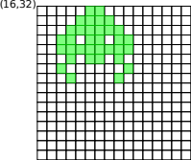

The character blitter uses 8x8 tiles, 512 are available, with the tiles being set using the set_blitter_chbitmap function, which takes a pointer to an array of 8 unsigned char. The character blitter tiles default to an 8x8 character ROM, with normal (characters 0 to 255 ) and bold characters (characters 256 to 511), but can be overwritten.

The colour blitter uses 16x16 tiles, 64 are available, with the tiles being set using the set_colourblitter_bitmap function, which takes a pointer to an array of 256 unsigned char.

void gpu_character_blit( unsigned char colour, short x1, short y1, unsigned char tile, unsigned char blit_size, unsigned char action ) | Blit an 8x8 character to (x1,y1) in colour.
void gpu_colourblit( short x1, short y1, short tile, unsigned char blit_size, unsigned char action ) | Blit a 16x16 full colour tile to (x1,y1).

void set_blitter_chbitmap( unsigned char tile, unsigned char *bitmap ) | Define one of the 256 8x8 character blitter tiles.
void set_colourblitter_bitmap( unsigned char tile, unsigned char *bitmap ) | Define one of the 64 16x16 colour blitter tiles.

Pixelblocks

The pixelblock operates as a software blitter, outputting pixels from an area of memory, such as a decoded image via the MINI-DMA controller.

gpu_pixelblock outputs { RGBM } pixels or converts 256 colour pixels to PAWSv2 colours via a colour-mapper table.

gpu_pixelblock24 converts 24bit RGB pixels to the PAWS RGBM or 255 GREYSCALE pixels before output.

The transparent parameter specifies a colour to treat as a ‘mask’ and not to be drawn. If ALL pixels are to be output, set transparent to TRANSPARENT.

void gpu_pixelblock_mode( unsigned char mode ) | Sets pixelblock to output in mode 0 ARRGGBB pixels, and in mode 1 to remap the pixels via the colour-mapper table.  Sets pixelblock24 to output in mode 0 GRRGGBB pixels, and in mode 1 to output GREYSCALE pixels.
void gpu_pixelblock_remap( unsigned char from, unsigned char to ) | Sets an entry in the colour mapper table, so that a 256 colour image will be converted to a 128 colour image via the remap table.
void gpu_pixelblock( short x, short y, unsigned short w, unsigned short h, unsigned char transparent. Unsigned char *buffer ) | Outputs a rectangle of pixels stored in memory, starting at (x,y) of size (width, height).
void gpu_pixelblock24( short x, short y, unsigned short width, unsigned short height, unsigned char transparent. Unsigned char *buffer ) | Outputs a rectangle of 24bit RGB pixels stored in memory, starting at (x,y) of size (width, height).

The pixelblock can also operate by taking pixels one-by-one, such as after calculation and drawing to the bitmap.

This mode is activated using gpu_pixelblock_start, and terminated with gpu_pixelblock_stop. Pixels are sent using gpu_pixelblock_pixel and gpu_pixelblock_pixel24 for { RGBM } and 24-bit RGB pixels respectively.

void gpu_pixelblock_start( short x, short y, unsigned short width ) | Set the GPU to start accpeting a rectangle of width pixels starting at (x,y) in PIXELBLOCK mode.  NOTE: No other GPU commands can be issued unitl gpu_pixelblock_stop() has been called.
void gpu_pixelblock_stop( void ) | Stop the PIXELBLOCK mode.
void gpu_pixelblock_pixel( unsigned char pixel ) | Send a pixel to the pixelblock and move to the next pixel.
void gpu_pixelblock_pixel24( unsigned char red, unsigned char green, unsigned char blue ) | Send a 24bit RGB pixel to the pixelblock and move to the next pixel.

NOTE: No other GPU operation can be started until gpu_pixelblock_stop has been called.

Miscellaneous/Utility Functions

void gpu_box( unsigned char colour, short x1, short y1, short x2, short y2, unsigned short width ) | Draws an outline rectangle with corners at (x1,y1) and (x2,y2) in colour, width pixels wide.  NOTE: Drawn by breaking into 4 lines.

To print C formatted strings to the bitmap, using the character blitter to output each character.

For gpu_printf the coordinate specify the top-left pixel for the output; for gpu_printf centre the coordinate specifies the top and the horizontal centre pixel for the output; for gpu_printf_vertical the coordinate specifies the bottom-left pixel for the output; for gpu_printf_centre_vertical the coordinate specifies the left and the vertical centre pixel for the output.

The size and action parameters are obeyed as per the character blitter.

void gpu_printf( unsigned char colour, short x, short y, unsigned char size, unsgined char action, const char *fmt,... ) | Outputs a string (maximum 80 characters) by repeatedly using the character blitter, starting at (x,y) in colour. Will size the characters and space accordingly. Action is detailed below.  NOTE: Escape characters are not processed, the corresponding character code is output as a character.
void gpu_printf_vertical( unsigned char colour, short x, short y, unsigned char size, unsgined char action, const char *fmt,... ) | Outputs a string (maximum 80 characters) by repeatedly using the character blitter, starting at (x,y) in colour. Will size the characters and space accordingly. Moving vertically upwards. Action is detailed below.  NOTE: Escape characters are not processed, the corresponding character code is output as a character.
void gpu_printf_centre( unsigned char colour, short x, short y, unsigned char size, unsigned char action, const char *fmt, ... ) | Outputs a string by repeatedly using the character blitter, with the top centred at (x,y) in colour. Will size the characters and space accordingly. Action is detailed below.  NOTE: Escape characters are not processed, the corresponding character code is output as a character.
void gpu_printf_centre_vertical( unsigned char colour, short x, short y, unsigned char size, unsigned char action, const char *fmt, ... ) | Outputs a string by repeatedly using the character blitter, with the top centred at (x,y) in colour. Will size the characters and space accordingly. Moving vertically upwards. Action is detailed below.  NOTE: Escape characters are not processed, the corresponding character code is output as a character.

Hardware Vector Blocks

void draw_vector_block( unsigned char block, unsigned char colour, short xc, short yc, unsigned char rotation ) | Starts the drawing of one of the 32 user definable vector (line drawn) objects, centred at (x,y) in colour. Rotation is by rotation*90°.
void set_vector_vertex( unsigned char block, unsigned char vertex, unsigned char active, char deltax, char deltay ) | Sets one of the 16 vertices in one of the 32 user definable vector (line drawn) objects.

The hardware vector block draws shapes that are defined by up to 15 lines, defined by 16 vertices. The lines are drawn in dot-to-dot fashion; the first line is defined by vertices 0 and 1; the second line is defined by vertices 1 and 2; until an inactive vertex is arrived at, or the last vertex is used.

The vertices are defined as deltas from (0,0) at the origin, with a range of -31 to 31.  From the asteroids.c code to setup the ship shape to draw the remaining lives.  void set_ship_vector( void ) {  set_vector_vertex( 0, 0, 1, 0, 0 );  set_vector_vertex( 0, 1, 1, 5, 10 );  set_vector_vertex( 0, 2, 1, 0, 6 );  set_vector_vertex( 0, 3, 1, -5, 10 );  set_vector_vertex( 0, 4, 1, 0, 0 );  set_vector_vertex( 0, 5, 0, 0, 0 );  }  Note that the deltas work the same as the bitmap coordinates, positive x is to the right, positive y to the bottom.  Note that the last vertex is set to active=0 so as to stop the vector drawer processing any further vertices in this block. | 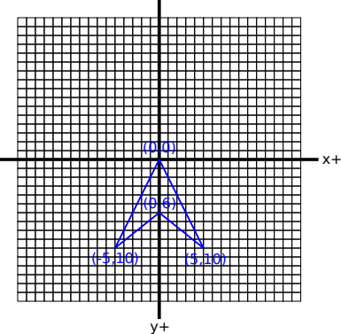

Tilemaps

Sprites

Text

Terminal

